Hi Taryn. Thanks for sharing your writing with me. My comments are a bit wordy but I wanted to make sure I explained my thought process as best I could. This is a great start to a featured creature and if you have any question about my comments or you want another set of eyes to help you edit as this gets closer to being published please let me know, I would love to help! Finally, I am sure you have done this but just for the sake of being thorough, consider going to the list of recently published featured creatures and look at how they organize the information. Here a link to the brown marmorated stink bug to get you started: http://entnemdept.ufl.edu/creatures/veg/bean/brown_marmorated_stink_bug.htm . Cheers!

common name: common backswimmer

scientific name: *Notonecta glauca* (Linnaeus) (Hemiptera: Notonectidae)

**Introduction – Distribution – Life Cycle – Behavior – Selected References**

**Introduction**

*Notonecta glauca*, commonly known as the common backswimmer, is an aquatic insect most easily recognizable by their long hind legs and ability to inflict wounds to humans with their proboscis.

**Distribution**

Although *Notonecta glauca* is most commonly found in freshwater ponds more inland, they can also be found in eutrophic bodies of water near the sea (Kjærstad et al. 2009).

**Description**

**Eggs: TBD**

**Nymphs:** Like many true bugs, nymphs of this species look like smaller adults. They do not have fully developed wings in the nymphal stage and have much shorter abdomens. They can also be more uniform in color. Often, their pronotum is not darker than the rest of the body like in the adults.

**Adults:** Adults of this species have a pale tan head and legs. The pronotum is darker than the head and the elytra can be a range of tan colors. The eyes are larger and dark red in color.

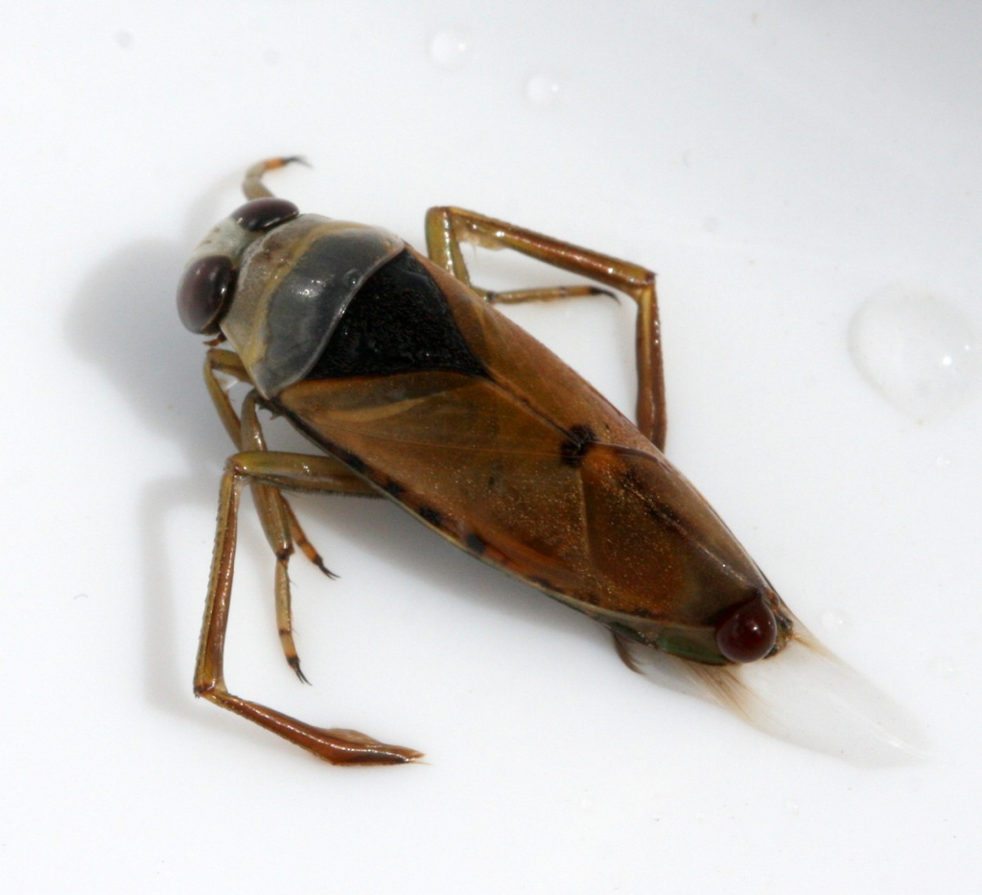

**Figure 1.** An adult *Notonecta glauca* (Linnaeus). Photograph by David Nicholls.

*Notonecta glauca* breathes by taking in atmospheric air, however its body is covered in hair-like structures called setae and microtrichia that aid them in their aquatic lifestyle. Setae are considered true hairs due to the fact that they have a socket from which they are contained residing in an adjacent cell deeper in the skin. Microtrichia originate from one cell on the surface. Its entire body except the pronotum (area behind the head), head, and legs are covered in these hairs. The hairs create an air film that allows the insect to breath while underwater and keeps their bodies dry (Kuru et al. 2011). The tips of these hairs are bent in the distal direction, or away from the body, and the area from the root up is pointed in the caudal direction, or towards the back of the body before bending distally. The setae tend to be larger and sparser in comparison to the denser patches of microtrichia. 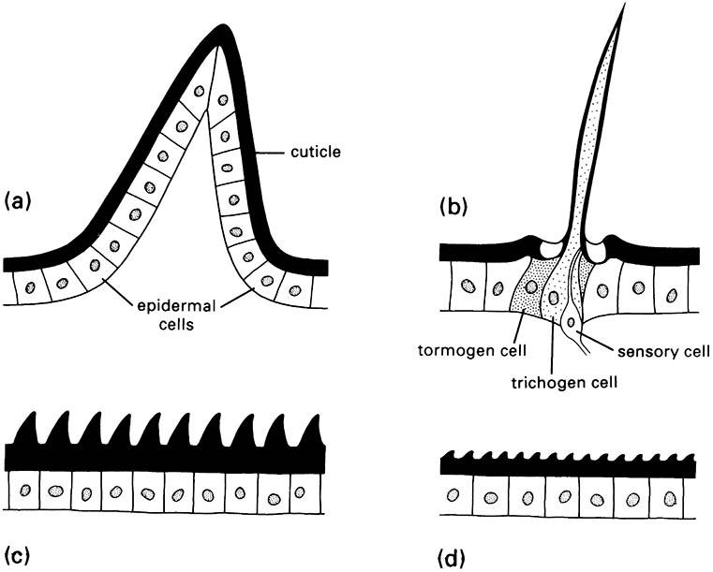

**Figure 2.** A) multicellular spine, B) seta, C) acanthae, and D) microtrichia. Diagram from After Richards & Richards 1979.

There is solely microtrichia present under the upper side of the elytra. Due to the density of the microtrichia air can be held in the film for up to 130 days. The underside of the body that resides under the elytra is sparser than the underside of the elytra itself, which can hold air for longer than the 130 days. Areas that are predominantly covered in setae will lose its air before the 130 days. This air film can be identified by a silvery sheen on the body (Kuru et al. 2011)

**Selected References**

Kjærstad G, Dolmen D, Olsvik HA, Tilseth E. 2009. The backswimmer *Notonecta glauca* L. (Hemiptera, Notonectidae) in Central Norway. Norwegian Journal of Entomology 56: 44-49.

Kuru PD, Schneider ES, Melskotte JE, Brede M, Leder A, Barthlott W. 2011. Superhydrophobic surfaces of the water bug *Notonecta glauca*: a model for friction reduction and air retention. Journal of Nanotechnology 2: 137-144.